**System Design Document**

**For**

**Dr. Brown Capstone Project Fall ‘23:**

**Portable Ultrasound Device for Coda-Wave Interferometry**

Team members:

Michael Kisellus, Matthew Baker, Layton Foxworthy, Kyle Fox, and Christopher Coppedge

|  |  |  |  |
| --- | --- | --- | --- |
| Version | Author | Change | Date |
| v1.0 | Michael Kisellus, Matthew Baker, Layton Foxworthy, Kyle Fox, and Christopher Coppedge | Initial draft | 9/29/2023 |
| v2.0 | Michael Kisellus | Revision from feedback provided on SDD_V1  section 1 to 2.1 | 10/20/2023 |
| v2.1 | Michael Kisellus | Revision from feedback provided on SDD_V1  section 2.1 to 6 | 10/21/2023 |
| v2.2 | Michael Kisellus | replace figure 2 and figure 3 | 10/27/2023 |
| v2.3 | Michael Kisellus | edit title page | 10/30/2023 |
| v2.4 | Kyle Fox | Completing 2.3 and 4.3 Sections | 10/31/2023 |
| v2.5 | Michael Kisellus | general editing for v3 turn in | 11/18/2023 |

TABLE OF CONTENT

1 INTRODUCTION 4

1.1 Purpose and Scope 4

1.2 Project Executive Summary 4

1.2.1 System Overview 4

1.2.2 Design Constraints 6

1.2.3 Future Contingencies 6

1.3 Document Organization 7

1.4 Project References 7

1.5 Glossary 8

2 SYSTEM ARCHITECTURE 8

2.1 System Hardware Architecture 9

2.2 System Software Architecture 11

2.3 Internal Communications Architecture 11

3 HUMAN-MACHINE INTERFACE 12

3.1 Inputs 12

3.2 Outputs 13

4 DETAILED DESIGN 14

4.1 Hardware Detailed Design 14

4.2 Software Detailed Design 16

4.3 Internal Communications Detailed Design 17

5 EXTERNAL INTERFACES 17

5.1 Interface Architecture 17

5.2 Interface Detailed Design 17

6 SYSTEM INTEGRITY CONTROLS 18

SYSTEM DESIGN DOCUMENT

*Overview*

*The System Design Document describes the system requirements, operating environment, system and subsystem architecture, files and database design, input formats, output layouts, human-machine interfaces, detailed design, processing logic, and external interfaces.*

# INTRODUCTION

Bridges are a vital infrastructure which is used daily by millions of people. Unfortunately like any other infrastructure the materials it is constructed of degrades over time to the point of failure. Discovering a bridge's subsurface cracks and failure points is vital to protecting the people who use that infrastructure daily. To assist structural engineers in this vitaly important task is The Portable Ultrasound Device (PUD). The PUD can be used to discover these normally invisible failure points and minimize the chances of a sudden failure event.

## Purpose and Scope

The PUD is a handheld ultrasound inspection device for inspecting a bridge/structural component for faults in the field. This handheld unit will have an independent power supply and will gather/store test data. The PUD is fully capable of its precise data collection duties while still being durable enough to withstand difficult environmental conditions such as shock from a fall, rain, and other environments a field tool will be exposed to.

## Project Executive Summary

This PUD unit will primarily consist of finding and integrating existing components into a cohesive system that matches our requirements. The production management for the PUD project is Agile Scrum. Dividing the PUD project into 3 sprints over the course of an 11 week timeline.

### System Overview

The PUD system will output a pulse signal to the transducer as shown in figure 2 point 1. The transducer then uses the piezoelectric effect to produce a 54K Hz test signal, this signal propagates into the connected concrete sample being tested as shown in figure 2 point 2. The signal then propagates to a second transducer placed on the concrete sample as shown in figure 2 point 3. Through the piezoelectric effect the second transducer converts the 54Hz signal into an electrical signal which is returned to the pud system to be processed as shown in figure 2 point 4.

The user diagram shown in figure 1 describes the options an operator can use to operate the PUD system. The operator may charge the battery or remove the SD card when the power is off to the main system. The main functionality is accessible when the operator turns the unit's power on. Allowing the operator to enter the test duration by repeatedly pressing the test duration button to cycle through the options. The values are displayed on the face plate shown on figure 6. The operator may press the start button to initiate the test. The operator may also stop the test before the test duration ends and save the results to a SD card.

Figure 1: User Diagram

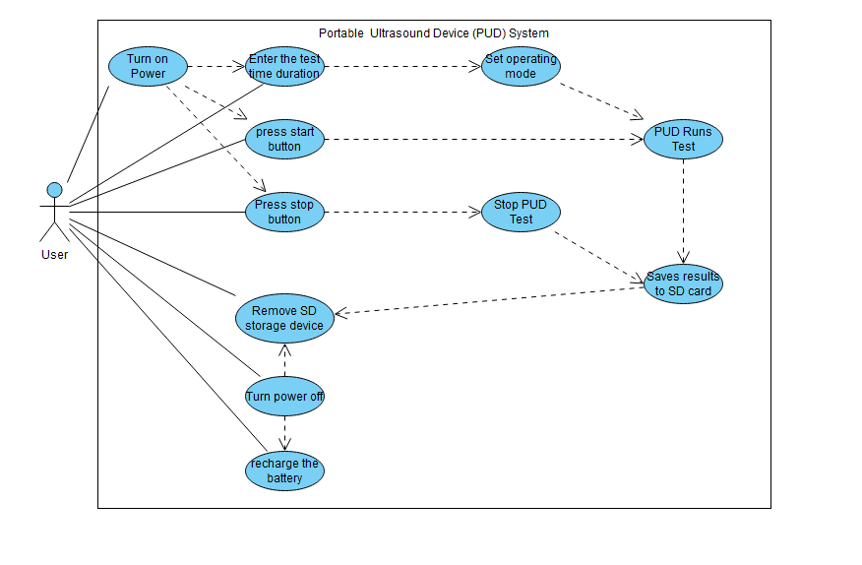

Figure 2: overall system diagram

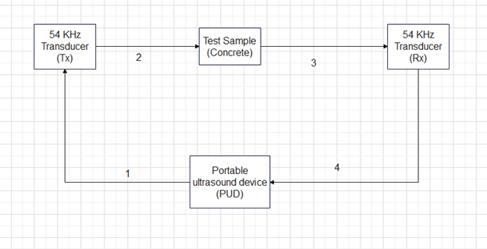

### Design Constraints

The design of our system will balance weight vs battery life, battery consumption vs cooling, and accuracy vs component price. Because one of the requirements of the system is to be portable we will be keeping the unit as light as possible. This comes in direct competition with battery life which also has its own requirement. Battery consumption and cooling are also going to have to be balanced to ensure the hardware, specifically the battery, stays within operating temperature. This would lead us to running the fans more but that increases battery consumption and decreases how long the system can be used in the field. Lastly, more accurate signal processing hardware costs more than its less accurate counterpart so our design uses components that are within budget and are also accurate enough for our application.

### Future Contingencies

The exact requirements of the system are dependent on the civil engineering laboratory, which serves as the primary stakeholder for the system. They will be the primary user of the system once it is operational so the requirements must match their expectations. Any changes to the system will depend on their wants and needs, and could be affected by potential miscommunications. The civil engineering lab already has some components of the final system, these are not going to change and are known to be good.

Operating with 500V requires specialized components and rated insulative material to protect the system from inadvertent grounds or component failure. If components fail during testing a higher voltage rated component may be purchased to replace insufficient performing parts.

The MOSFET component used must switch on and off quickly to fulfill its purpose. If the component is unable to meet specifications during testing a better/ more expensive component may need to be purchased to replace this component.

The oscilloscope used to sample the return signal needs to sample extremely quickly to capture the return signal in detail. This component may need to be replaced if testing reveals the sample rate to be insufficient.

## Document Organization

The document adheres to the organizational structure and formatting prescribed by the course. Every section, heading, and subheading has been aligned with the template guidelines to maintain a consistent and professional appearance. By following the provided instructions and formatting guidelines, we aimed not only to meet the basic requirements but also to contribute to the overall uniformity of documentation between the multiple teams. This approach ensures that the professors and TAs can easily navigate the document.

Part 1 contains the INTRODUCTION which has 8 subsections: Purpose and Scope, Project Executive Summary, System Overview, Design Constraints, Future Contingencies, Document Organization, Project References, and the Glossary. Overall this section describes the system as a whole, constraints,contingencies and the documentation associated with the system.

Part 2 contains the SYSTEM ARCHITECTURE which has 3 subsections: System Hardware Architecture, System Software Architecture, Internal Communications Architecture. Overall this section describes the system hardware and software architecture for the PUD system. The hardware section is subdivided by systems.

Part 3 contains the HUMAN-MACHINE INTERFACE which has 2 subsections: Inputs and Outputs. Overall this section describes the inputs a user can make and the outputs the PUD system will produce.

Part 4 contains the DETAILED DESIGN which has 3 subsections: Hardware Detailed Design, Software Detailed Design, Internal Communications Detailed Design. Overall this section provides an in depth explanation of the systems used to construct the PUD system.

Part 5 contains the EXTERNAL INTERFACES which has 2 subsections: Interface Architecture and Interface Detailed Design. Overall this section describes other systems the PUD system must interface with to operate. This section is small because the system is self contained and does not communicate to exterior systems during operation.

Part 6 contains the SYSTEM INTEGRITY CONTROLS. Overall this system has to do with data security and software protections. This section is small due to the unit not requiring data protection/ not sensitive information.

## Project References

This section provides a bibliography of key project references and deliverables that have been produced before this point.

International Electrotechnical Commission (2013). Degrees of protection provided by enclosures (IP Code) (IEC 60529). Retrieved from https://website.iec.ch/publication/2452

Parts references are placed at the end of the document in table 3.

## Glossary

Supply a glossary of all terms and abbreviations used in this document. If the glossary is several pages in length, it may be included as an appendix. shown in table 1.

Table 1: glossery

|  |  |
| --- | --- |
| IP Rating [IPAB] | Ingress Protection rating as codified under the IEC 60529 standard, where A is the device’s resistance to solid particle such as dust from zero (no protection) to 6 (most protection) and B is the device’s resistance to liquids from zero (no protection) to 9K (most protection). (International Electrotechnical Commission [IEC], 2013)  An IP55 rating means:  5-Ingress of dust is not entirely prevented, but it must not enter in sufficient quantity to interfere with the satisfactory operation of the equipment.  5-Water projected by a nozzle (6.3 mm) against enclosure from any direction shall have no harmful effects. |
| PUD | Portable ultrasound device |
| LED | Light emitting diode |
| TBD | To be determined |

# SYSTEM ARCHITECTURE

This section outlines the overall system architecture, including both software and hardware architecture for the PUD system and subsystems.

Figure 3 shows the PUD physical components and their interactions. Point 1 shows that the cooling fan receives power to operate from the battery. Point 2 shows that the analog to digital converter delivers its data to the central control chip. Point 3 shows that the pulse generator is controlled by the central control chip. Point 4 shows that the pulse generator controls the MOSFET gating on or off. Point 5 shows that The MOSFET outputs to the Transducer. Point 6 shows that the central control chip transfers data to the SD card. Point 7 shows that the central control chip monitors the battery voltage. Point 8 shows that the cooling fan is controlled by the central control chip. Point 9 shows that the status LEDs are controlled by the central control chip. Point 10 shows that the central control chip receives power from the battery. Point 11 shows that the status LEDs are powered by the battery. Point 12 shows that the transducer transmits a signal to the analog to digital converter. Point 13 shows that the MOSFET input is provided by the DC to DC converter. Point 14 shows that the DC to DC converter is powered by the battery.

Figure 3 : Portable ultrasound device (PUD) internal components block diagram

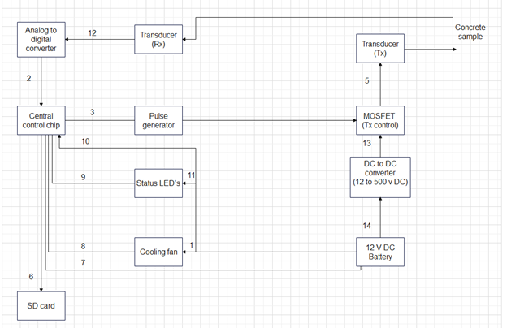

## System Hardware Architecture

In this section, describe the overall system hardware and organization. Include a list of hardware components (with a brief description of each item) and diagrams showing the connectivity between the components. If appropriate, use subsections to address each subsystem.

**Cooling System**

The cooling system consists of multiple 80mm fans each connected to an integrated fan controller and temperature sensor to operate independently from one another to ensure that if one fan goes down the other(s) can still operate as well as making sure each area within the case gets the airflow that it requires. The fans will be placed on either end of an inner metal frame to drive the airflow over the components in the most efficient manner possible. The fan’s RPM rate will be tied to the system’s internal temperature via the following curve:

Figure 4: Cooling fan behavior chart

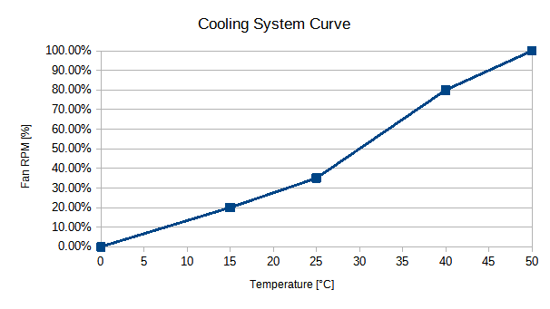

While the system’s design takes into account the possibility for the fans to run at maximum for the entire operating time, this thermal curve is in keeping with industry standards for keeping a computer system cooled while preventing too much current and power use from the internal power supply and thus preventing premature power drain.

Parts List:

Orion Fans OD8025-12HBIP55 Fan, 12VDC, 2.2 Watts at 0.18 Amps

EMC2101 integrated fan controller and thermocouple, 3V DC connected to central board.

5052-H32 Aluminum sheet metal with a thickness of 0.4mm, cut and folded to shape.

**Electrical System**

The PUD electrical system consists of a 12 v battery bank which is used to power various loads. Such as LED’s and cooling fans. There is a subsystem for charging the battery which is disconnected through an externally operable switch. The high voltage section consists of a 12v DC to 500v DC converter and a capacitor bank to maintain voltage. Electrical schematic shown in figure 3 below.

Parts list for electrical systems are shown in table 2 but parts may be replaced with equivalent parts.

Figure 5: PUD Electrical system

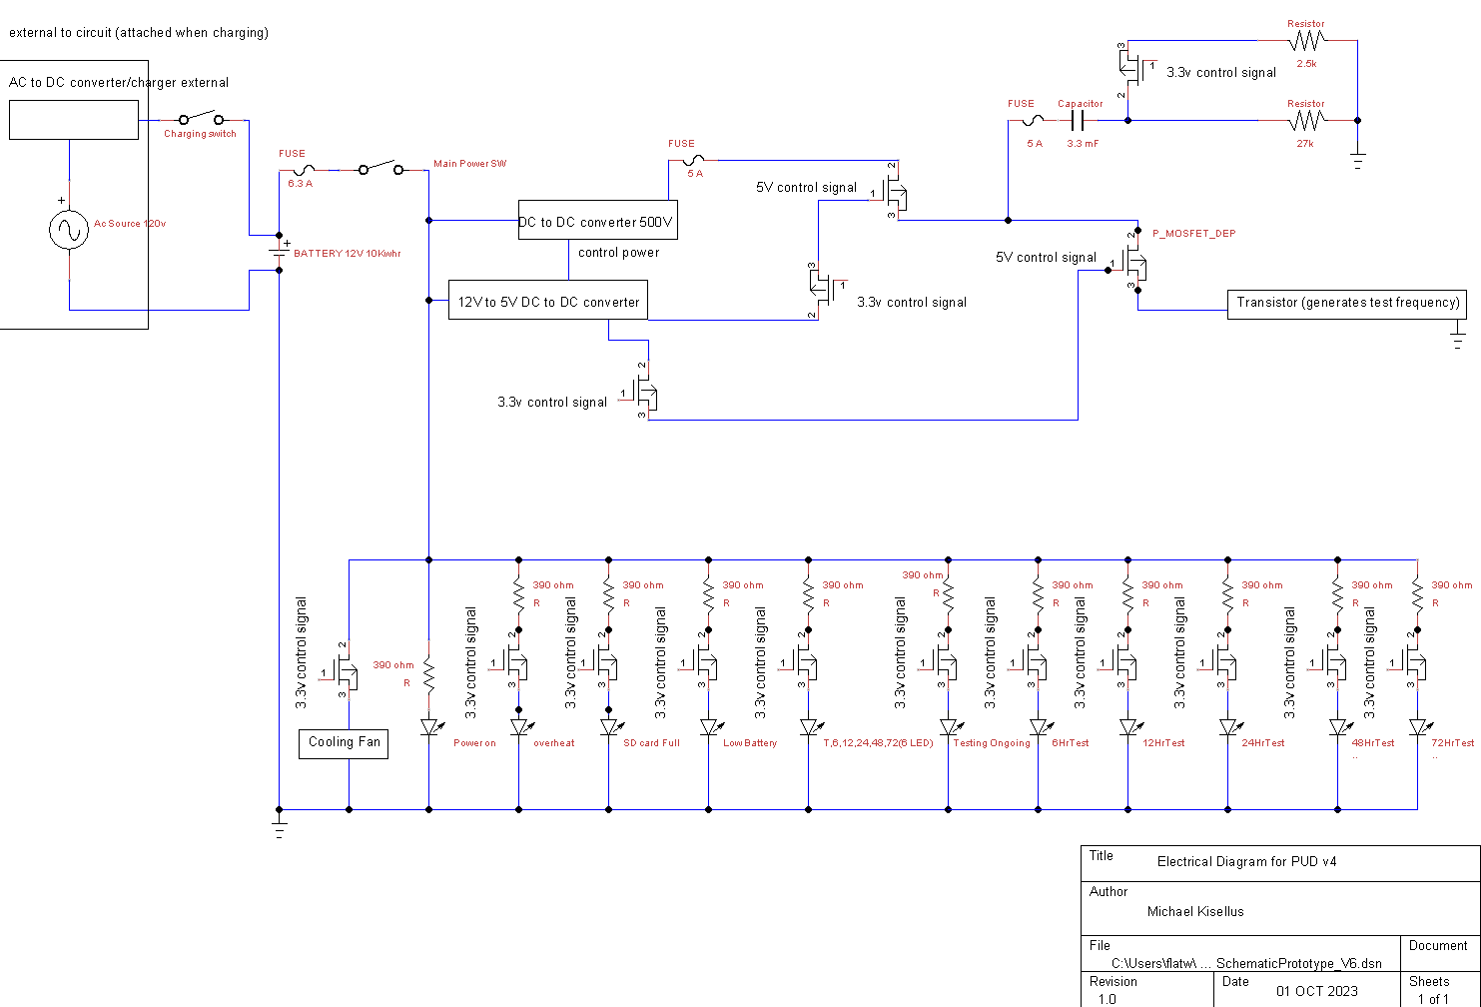

## System Software Architecture

A system software architecture was not included as it was not clear what exactly the software would need to do. Initially, it was thought that the software was going to need to take raw data from a transducer and convert it into a usable format. Recently the requirements of our project were altered so that the software no longer needs to do this. As a plan for how this is going to be achieved becomes more concrete a Software Architecture will be created as parts and components become available to wire in.

## Internal Communications Architecture

The internal communications will consist of USB, Digital IO, and UART. The UART will allow us to program the microcontroller. USB will be used to control the microcontroller from the onboard PC and a different USB will be used to control the Oscilloscope. The microcontroller will use the digital IO pins to control the HMI and pulse control.

Any communication between the internal pc and the switches will be made through the microcontroller.

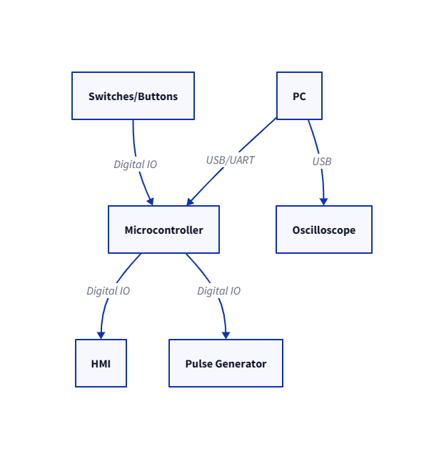

# HUMAN-MACHINE INTERFACE

The PUD system will have input from the user to start the system and to determine how long the system should operate. This will be performed through physical buttons. As for outputs the PUD will have LED indicators to display the system’s status to the operator. Additionally, a removable SD card will be able to be extracted from the system after it has gathered the desired data.

## Inputs

The PUD system inputs will be physical buttons that send a voltage signal to the microcontroller. Because it is a simple 2-state button the PUD will have the input to the microcontroller be a simple binary input. The buttons will correspond to modes that set the time the system will be in operation. This simplicity will make I/O controls simple and reliable.

The front panel physical button I/O options will be “Test System”, “6 Hour”, “12 Hour”, “24 Hour”, “48 Hour”, “72 Hour”, “Start Test” “Select Test Duration” and “Stop Test”. As shown in figure 6.

Figure 6: Input panel for PUD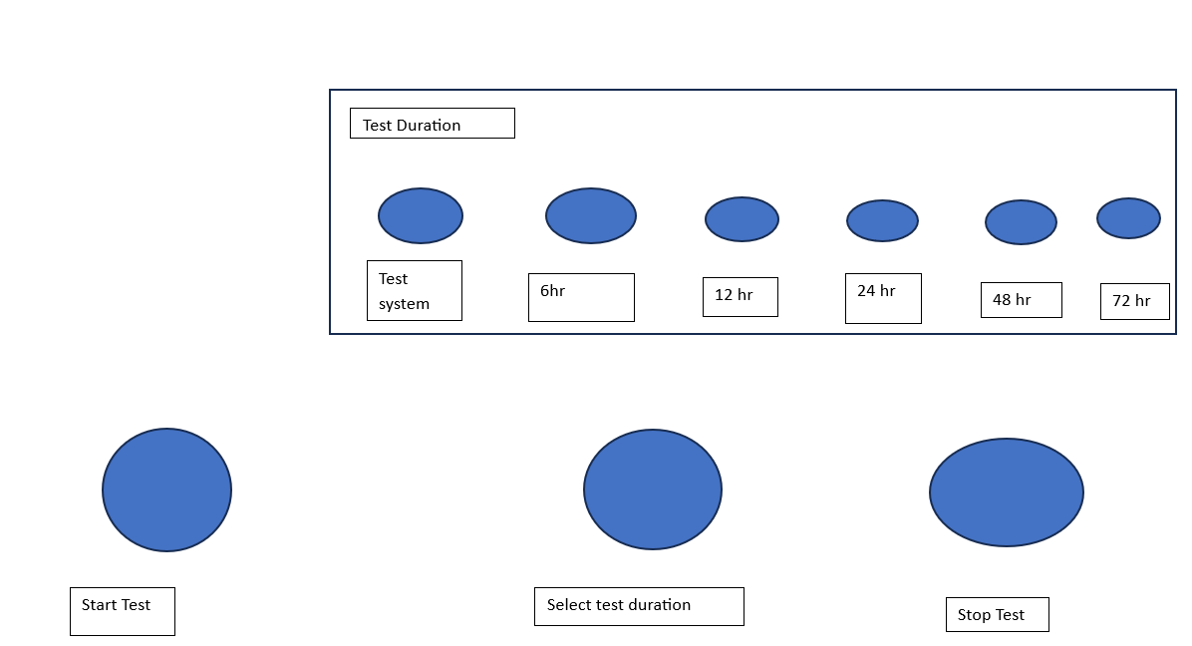

## Outputs

The outputs from our system come in two different forms. The data from the operation of the system, and the indicators that tell the operator the status of the system. The operator indicators will be presented on LEDs and the system’s output data from the concrete measurement will be stored on an SD card.

The operator’s indicators will be the representation of binary values in our microcontroller. The implementation of this will depend on the voltage the microcontroller is able to output so if it is not able to power the LED we may need a relay to switch the LED on. The indicators will include “Power Available”, “Low Battery”, “High Temperature”, “SD Card Full”, “Unit Charging Capacitor” and more if needed.

The data the system collects about the concrete will need to be converted to a digital signal and stored. This will then be written to an SD card for the operator to retrieve when the system is done with its operation. The retrieval will require the case to be opened. This helps protect the SD card against the weather. The output file on the SD card will mostly depend on the microcontroller and the file type used in the lab that processes the information.

Figure 7: Output panel for PUD

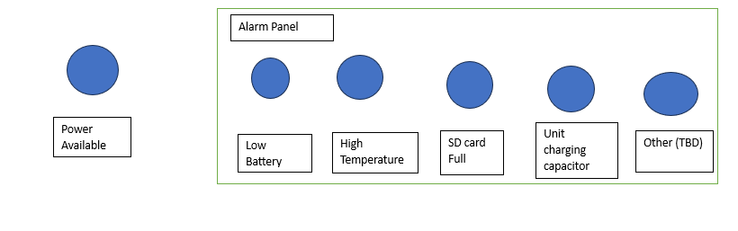

# DETAILED DESIGN

This section provides the information needed for a system development team to actually build and integrate the hardware components, code and integrate the software modules, and interconnect the hardware and software segments into a functional product. Additionally, this section addresses the detailed procedures for combining separate COTS packages into a single system. Every detailed requirement should map back to the FRD, and the mapping should be presented in an update to the RTM and include the RTM as an appendix to this design document.

## Hardware Detailed Design

The low level hardware design is split into 5 distinct parts. The microcontroller and control system, the output signal, the input signal, the environment control, and the power system.

**Environment Control and Cooling System**

The cooling system consists of pre-fabricated aluminum heat sinks attached to the various “hotspots'' of the system (CPUs, Capacitor bank, DC-DC convertor, etc.) via thermally-conductive and electrically neutral compounds such as grease or adhesive pads. These components are then attached via standoffs to a grounded aluminum frame to act as a heat spreader and to prevent electrical short circuits. This frame will consist of sheet aluminum bent into a U-shaped frame to house the actual internal components, with cutouts for wires and connectors, and a removable aluminum top panel fit by friction to enclose the “box” to better channel air across the components. The actual action of cooling the system is provided by Orion Fans OD8025-12HBIP55 fans placed into the casing so that one acts as an intake fan and the second as an exhaust fan. These fans are then connected to the aluminum box via plastic shrouds that will channel the air through the aluminum frame for maximum static pressure. Each fan in and of itself has an IP55 rating to aid in the overall elemental resistance of the unit. In the event that the temperature inside the case approaches the thermal cutoffs/damage zones for the components (i.e. 131 degrees Fahrenheit for the DC-DC converter), the fans will be spun up to maximum RPM to prevent thermal throttling or damage to the components and will reduce RPMs according to a programmed hysteresis curve in the system’s firmware. The source of the temperature information will from the EMC2101 integrated fan controller breakout boards in the main body each of which will be in a different position within the case (e.g.beside the DC-DC converter) to ensure that each fan can operate independently as well as run at a speed that will aid in cooling local components..Additional fans and controllers may be added to provide airflow and cooling to other components inside the case (i.e. battery, capacitors, etc.). Each fan draws 2.2 watts at 0.18 amps, and each board requires a 3-3.6V supply voltage to operate effectively which it can receive from the Raspberry Pi Pico at the heart of the system. The fan controller boards connect to the fans via a standard 4-pin fan connector and to the Pico via a V_in, GND, and 3V pinout. The aluminum selected for the frame is 5052-H32 sheet aluminum at a thickness of 0.4mm which has strong corrosion resistance and is used in marine environments.

**Electrical and Power System**

The electrical system consists of 2 main buses. Note: electrical bus bars are used to distribute power. A 12 V DC bus and a 500 V DC bus are used.

The 12 V DC bus consists of 2 loops. The first loop is used to recharge the LiFePO4 12V 50Ah Lithium Iron Phosphate Battery. The battery is connected using 6 AWG (16mm²) 13 Inch Battery Interconnect Cable to the exterior of the casing and is accessible without opening the case. A Battery Isolator Switch for Car Vehicle RV and Marine (On/Off) is used to isolate the battery charging loop when not in use.The battery charger used is a 5A & 10A 12V Smart Battery Charger with LCD Display for Lead Acid and Lithium (LiFePO4) Batteries. The second loop connects the battery to the 12 V DC load bus which powers the various loads of the system.The battery has a switch to open this loop and turn off the system. The battery connects to the 10 Position Wire to Board Terminal Block Horizontal with Board. This is used to connect the various 12 v loads. Including the LED indicating lights which require a 453 Ohms ±1% 0.25W, 1/4W Through Hole Resistor Axial Metal Film to reduce voltage and current to 3.3v and 20mA for the LED to operate. The LED uses a Transistor’s: Bipolar (BJT) Transistor NPN 36 V Through Hole TO-92-3 to receive signals from the controlling chip to turn on or off. The cooling fan receives power from this bus. The controlling chip receives its power from this bus. The DC 12v 24v to 5v Step Down Converter Regulator 5A 25W Power Adapter Reducer for Car Electronics Truck Vehicle Boat Solar System (Accept DC 8-40V Inputs) receives power from this bus and its output is used as control power on the Enclosed DC DC Converter 1 Output 0 ~ 500V 20mA 13V Input. The 12V DCto 500V DC converter receives its main power from this bus and sends power to the 500V bus.

The 500V DC bus starts at the 12V DC to 500V DC converter and is used to charge a 3300 µF 500 V Aluminum Electrolytic Capacitor which acts as a voltage regulator for normal operation.Ancor Marine Grade Primary Wire and Battery Cable is used for the 500 v portion of the circuit to connect the circuit components. A 47 kOhms ±5% 50W Wirewound Chassis Mount Resistor is used in series with the capacitor to prevent current from exceeding the 20mA limit of the converter while charging the capacitor. Finally a MOSFET N-Channel 500 V 14A (Tc) 30W (Tc) Through Hole TO-220FP is used to gate the 500 V DC source on for 2*10^-6 sec. This pulse then travels to the transducer and leaves the PUD system. Figure 3 above displays the electrical schematic.

**Microcontroller and Control**

This part of the PUD can be affectionately considered the brains of the PUD. The microcontroller and control system handles both user inputs, timing of data collection from the input signal, control of the output signal, and allows for user retrieval of data from the SD card.

This system uses the bus architecture described earlier to communicate with both the SD card and the ADC. This allows data to move through the microcontroller to the SD card with minimal latency for further data collection.

**Output Signal**

This is the 500V DC signal that pings the transducer. The system uses a DC-DC converter to charge 500V and release a 2 microsecond pulse to the transducer allowing the semiconductive nature of the crystal to ring. This is activated by the microcontroller and is timed to allow the input signal to be unaffected by the “strike” of the output transducer.

**Input Signal**

The input signal is a 1V peak signal that is fed into a high speed high bandwidth ADC. This ADC converts the analog signal into a digital stream that is fed into the microcontroller. This signal is the representation of the concrete health, this signal must be captured in its entirety and for its whole duration. This is done by using the ADC filtering functions to remove noise and capture the whole waveform for data processing. Once the ADC has captured a portion of the signal, the microcontroller moves the data over SPI to the SD card for processing by the data analysis program, which is off system.

## Software Detailed Design

Much of the software design is low level hardware connection. This allows the SPI and UART bus architecture to be controlled properly from the microcontroller. The system will be programmed in python. The system will also format the data into a .mat file type so when the SD card is read, the data can be easily processed. Much of the PUD is hardware based and software is only a supporting element, and much can not be defined this early into the design process.

## Internal Communications Detailed Design

USB Communication will be the method in which the PC will communicate with the microcontroller and oscilloscope. The oscilloscope will be controlled through standard software that runs on the PC. This software is sourced from the manufacturer. The microcontroller will communicate over a UART/USB bridge that allows for data to be transferred. The PC will run a custom program that we design that allows for UART data transmission over USB. Data that is sent between the computer and microcontroller will consist of unit start and stop markers for logging only. 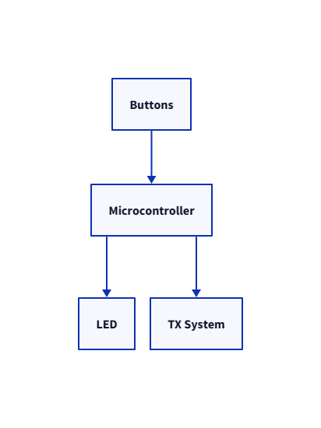

The microcontroller will use its Digital IO pins to turn LEDs on and off for the HMI and send a pulse to the TX portion of the system. The LEDs will be controlled by the outputs of the microcontroller. The pulse will be timed to be as short as possible, however to ensure accuracy that will feed into a timer circuit to keep the time consistent.

# EXTERNAL INTERFACES

With the system being self-contained there should be no external interfaces under the scope of the PUD project. The only possible example could be the SD card being extracted from the PUD system and being read by a lab computer. Because of this interaction the PUD will format our data such that MATLAB will be able to read the data from the SD card. Otherwise the power, ultrasonic outputs, and ultrasonic inputs are all self-contained without the PUD system.

## Interface Architecture

It is currently unclear regarding the data type the civil engineering lab typically uses when processing ultrasonic concrete scans so the PUD will be changing the output from the microcontroller to match that.

## Interface Detailed Design

The data format requirement may come in the future from the civil engineering lab such that it can process the PUD data the same way the lab processed the data they produced. The components will be permanently connected and the data flow will be one direction so there shouldn’t be a need for hand-shaking protocols. The current understanding is that any file format that can be imported into MATLAB will be acceptable.

# SYSTEM INTEGRITY CONTROLS

The data collected by the PUD system is not inherently sensitive or private so security is not the highest priority. There will be a physical lock on the PUD outer casing for safety purposes but this will also protect the data the system collects. Physical protection of the device is the responsibility of the user of the system. Verification of the data will come from the lab that analyzes the data so this is not within the scope of the PUD project.

Table 2: electrical components parts list

|  |  |
| --- | --- |
| part number | Part specification and description |
| 1 | 3300 µF 500 V Aluminum Electrolytic Capacitors Radial, Can - Screw Terminals 54mOhm @ 100Hz 20000 Hrs @ 85°C |
| 2 | Enclosed DC DC Converter 1 Output 0 ~ 500V 20mA 13V Input  3838-HighVoltagePowerSupplyAHV12V500V20MAWTB-ND - Tape & Box (TB) |
| 3 | DC 12v 24v to 5v Step Down Converter Regulator 5A 25W Power Adapter Reducer for Car Electronics Truck Vehicle Boat Solar System (Accept DC 8-40V Inputs) |
| 4 | White, Cool 9000K LED Indication - Discrete 3.2V Radial |
| 5 | 5A & 10A 12V Smart Battery Charger with LCD Display for Lead Acid and Lithium (LiFePO4) Batteries |
| 6 | 6AWG (16mm²) 13 Inch Battery Interconnect Cable |
| 7 | LiFePO4 12V 50Ah Lithium Iron Phosphate Battery |
| 8 | Battery Isolator Switch for Car Vehicle RV and Marine (On/Off) |
| 9 | Ancor Marine Grade Primary Wire and Battery Cable |
| 10 | N-Channel 500 V 14A (Tc) 30W (Tc) Through Hole TO-220FP |
| 11 | Starelo 5pcs 19mm Momentary Push Button Switch Black Shell, IP65 Waterproof Push Button Switch,Stainless Steel 1 Normally Open Without LED. |
| 12 | 47 kOhms ±5% 50W Wirewound Chassis Mount Resistor |
| 13 | N-Channel 20 V 6.8A (Ta) 510mW (Ta), 6.94W (Tc) Surface Mount TO-236AB |
| 14 | 390 Ohms ±5% 0.5W, 1/2W Through Hole Resistor Axial Flame Retardant Coating, Safety Carbon Film |
| 15 | 21 Circuit 0.374" (9.50mm) Barrier Block Connector Screws |
| 16 | 5 A 600 V AC 500 V DC Fuse Cartridge, Ceramic Requires Holder 5mm x 20mm |
| 17 | Fuse Block 10 A 600V 1 Circuit Cartridge Chassis Mount |
| 18 | 6.3 A 250 V AC DC Fuse Cartridge, Glass Requires Holder 5mm x 20mm |
| 19 | ANSI Z535 Safety Labels - Hazardous Voltage Inside  Hazard labels with strong adhesive backing ideal for rugged use |
| 20 | 50ft - 1/4 inch & 1/2 inch PET Expandable Braided Sleeving – Black – Alex Tech Braided Cable Sleeve |
| 21 | XHF 3/4" Strong Back-Glue Self Adhesive Black Cable Zip Tie Mounts 100pcs with 8" Zip Ties, Screws, UV Protection Outdoor Sticky Wire Fasteners Cable Clips Management Anchors Organizer Holders Squares |
| 22 | Miuzei PCB Board Prototype Kit for Electronic Projects, Circuit Solder Double-Side Board with 40 Pin 2.54 mm Male to Female Headers Connector, 2P&3P Screw Terminal Block, Solder Flux, Solder Wire |
| 23 | 330 Pcs M2 Male Female Brass Hex Spacer Standoffs Screws Nuts, Brass Spacer Hex Column Screw Nut Assortment Kit, Threaded Pillar Standoffs Screws for PCB Circuit Board Motherboard Standoffs Spacer |
| 24 | Breadboard, Surface Mount Plated Surface Mount Pad (Square) 0.100" (2.54mm) |
| 25 | 2.7 kOhms ±5% 120W Wirewound Chassis Mount Resistor |
| 26 | Heat Sink TO-218, TO-220, TO-247 Aluminum 14.0W @ 70°C Board Level, Vertical  or  Heat Sink TO-220 Aluminum 2.5W @ 50°C Board Level |
| 27 | TBD |
| 28 | TBD |
| 29 | TBD |
| 30 | TBD |

# References

“021706.3TXP Littelfuse Inc. | Circuit Protection | DigiKey.” *DigiKey*, www.digikey.com/en/products/detail/littelfuse-inc/021706-3TXP/3425317. Accessed 21 Oct. 2023.

“05200005ZXGY Littelfuse Inc. | Circuit Protection | DigiKey.” *DigiKey*, www.digikey.com/en/products/detail/littelfuse-inc/05200005ZXGY/554334. Accessed 21 Oct. 2023.

“0ADKC5000-Be Bel Fuse Inc. | Circuit Protection | Digikey.” *DigiKey*, www.digikey.com/en/products/detail/bel-fuse-inc/0ADKC5000-BE/7404459. Accessed 21 Oct. 2023.

“100ft - 1/2 Inch Pet Expandable Braided Sleeving - Amazon.Com.” *Amazon*, www.amazon.com/100ft-Expandable-Braided-Sleeving-braided/dp/B074GMNW7T. Accessed 21 Oct. 2023.

“12-48V Battery Isolator Switch for Car Vehicle RV and Marine (on/off): Eco-Worthy.” *ECO*, www.eco-worthy.com/products/12-48v-battery-isolator-switch-for-car-vehicle-rv-and-marine-on-off?variant=40589578567868. Accessed 21 Oct. 2023.

“2-1546306-1 TE Connectivity AMP Connectors - DigiKey Electronics.” *DigiKey*, www.digikey.com/en/products/detail/te-connectivity-amp-connectors/2-1546306-1/1136667. Accessed 21 Oct. 2023.

“330 PCS M2 Male Female Brass Hex Spacer Standoffs Screws ... - Amazon.Com.” *Amazon*, www.amazon.com/Standoffs-Assortment-Threaded-Circuit-Motherboard/dp/B0BZYTC581. Accessed 21 Oct. 2023.

“577002B00000G Aavid, Thermal Division of Boyd Corporation - Digikey.” *DigiKey*, www.digikey.com/en/products/detail/aavid-thermal-division-of-boyd-corporation/577002B00000G/102507. Accessed 21 Oct. 2023.

“5A 12V Automatic Smart Battery Charger and Maintainer with LCD Display for Lead Acid and Lithium (LiFePO4) Batteries: Eco-Worthy.” *ECO*, www.eco-worthy.com/products/5a-12v-automatic-smart-battery-charger-and-maintainer-with-lcd-display-for-lead-acid-and-lithium-lifepo4-batteries?variant=42350017052921. Accessed 21 Oct. 2023.

“6AWG (16mm2) 13 Inch Battery Interconnect Cable: Eco-Worthy.” *ECO*, www.eco-worthy.com/products/6awg-16mm-13-inch-battery-interconnect-cable?variant=34593133625509. Accessed 21 Oct. 2023.

“Als30a332np500 Kemet | Capacitors | Digikey - Digi-Key Electronics.” *Digikey*, www.digikey.com/en/products/detail/kemet/ALS30A332NP500/3462159. Accessed 21 Oct. 2023.

“Amazon.Com: XHF 3/4" Strong Back-Glue Self Adhesive Black Cable Zip Tie ...” *Amazon*, www.amazon.com/XHF-Back-Glue-Protection-Fasteners-Management/dp/B08F77YVYB. Accessed 21 Oct. 2023.

“ANCOR Marine Grade Primary Wire and Battery Cable - Amazon.Com.” *Amazon*, www.amazon.com/Ancor-Marine-Grade-Primary-Battery/dp/B07ZSDK651. Accessed 21 Oct. 2023.

“ANSI Z535 Safety Labels - Hazardous Voltage Inside.” *Seton*, www.seton.com/ansi-z535-safety-labels-hazardous-voltage-inside-l5476.html?utm_campaign=%5BNB%5D_Labels_Catch%2BAll_PLA-S_High_All_PC-02_GGL_SUS&utm_source=google&utm_medium=cpc&utm_term=&matchtype=&device=c&adgroupid=&gclsrc=aw.ds&gclid=CjwKCAjwseSoBhBXEiwA9iZtxo15KyzhNfMKE5oyzbC-vorhbGmpge9ewSppeK7ReCrhPLgh6Yt0NRoCVhcQAvD_BwE. Accessed 21 Oct. 2023.

“C503C-Wan-CCADB232 Creeled, Inc. | Optoelectronics | DigiKey.” *DigiKey*, www.digikey.com/en/products/detail/creeled-inc/C503C-WAN-CCADB232/2681196. Accessed 21 Oct. 2023.

“CF12JT390R Stackpole Electronics Inc | Resistors | Digikey.” *DigiKey*, www.digikey.com/en/products/detail/stackpole-electronics-inc/CF12JT390R/1741140. Accessed 21 Oct. 2023.

“DC 12V 24V to 5V Step down Converter Regulator 5A 25W Power Adapter ...” *Amazon*, www.amazon.com/Converter-Regulator-Adapter-Reducer-Electronics/dp/B07Q5W1BG3. Accessed 21 Oct. 2023.

“High Voltage Power Supply AHV12V500V20MAW Analog Technologies | Power ...” *DigiKey*, www.digikey.com/en/products/detail/analog-technologies/High-Voltage-Power-Supply-AHV12V500V20MAW/18621897. Accessed 21 Oct. 2023.

“LiFePO4 12V 50ah Lithium Iron Phosphate Battery: Eco-Worthy.” *ECO*, www.eco-worthy.com/products/lifepo4-12v-50ah-lithium-iron-phosphate-battery?currency=USD&variant=42491122712825&utm_medium=cpc&utm_source=google&utm_campaign=Google+Shopping&stkn=ac7b7d784bf0&gclid=CjwKCAjwgsqoBhBNEiwAwe5w02e_e41oUWis8aF0zZ64SqB2gfhDZQGvhFikRSAGGwQNgwVP8l8POBoCaacQAvD_BwE. Accessed 21 Oct. 2023.

“Miuzei PCB Board Prototype Kit for Electronic Projects, Circuit Solder ...” *Amazon*, www.amazon.com/Miuzei-Including-Prototype-Connector-Terminal/dp/B07PS4VCDD. Accessed 21 Oct. 2023.

“Ohmite Distributor | DigiKey Electronics.” *DigiKey*, www.digikey.com/en/supplier-centers/ohmite. Accessed 21 Oct. 2023.

“PMV16XNR Nexperia USA Inc. | Discrete Semiconductor Products | DigiKey.” *DigiKey*, www.digikey.com/en/products/detail/nexperia-usa-inc/PMV16XNR/5395791. Accessed 21 Oct. 2023.

“Ra-T2X-38E Ohmite | Fans, Thermal Management | DigiKey.” *DigiKey*, www.digikey.com/en/products/detail/ohmite/RA-T2X-38E/2416488. Accessed 21 Oct. 2023.

“SBBSM2106-1 Chip Quik Inc. | Prototyping, Fabrication Products | DigiKey.” *DigiKey*, www.digikey.com/en/products/detail/chip-quik-inc/SBBSM2106-1/5978238. Accessed 21 Oct. 2023.

“Starelo 5pcs 12mm Momentary Push Button Switch Black Shell with Pre ...” *Amazon*, www.amazon.com/Momentary-Push-Button-Switch-Without/dp/B09BKZ68HF. Accessed 21 Oct. 2023.

“STF19NM50N Stmicroelectronics | Discrete Semiconductor Products | DigiKey.” *DigiKey*, www.digikey.com/en/products/detail/stmicroelectronics/STF19NM50N/2346299. Accessed 21 Oct. 2023.

“TE120B2K7J Te Connectivity Passive Product | Resistors | DigiKey.” *DigiKey*, www.digikey.com/en/products/detail/te-connectivity-passive-product/TE120B2K7J/14308543. Accessed 21 Oct. 2023.